DAY 3 LAB EXPERIMENTS

NAME: VIGNESHVAR S
Reg No : 192424187
Date : 18/12/2025

EXP_11 You have been tasked with creating a simple plot to show the sales of a product over time.
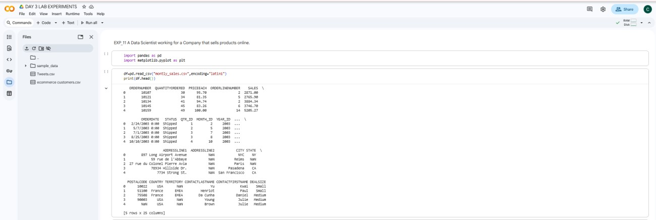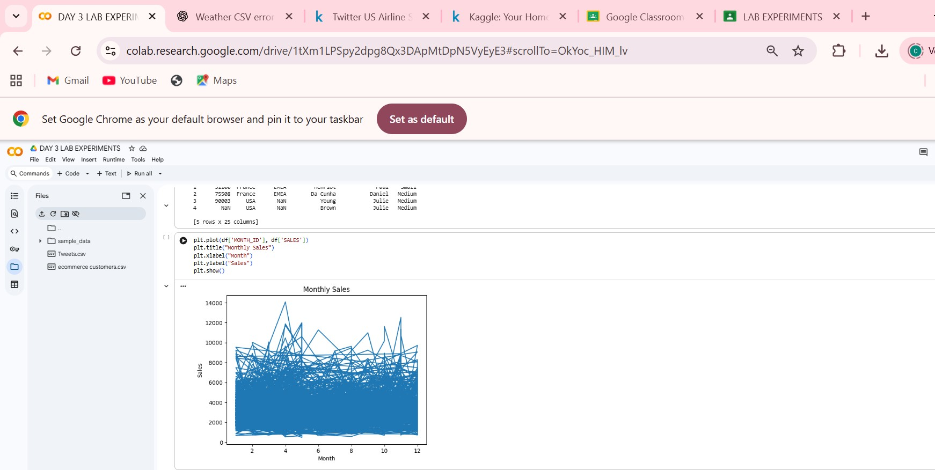
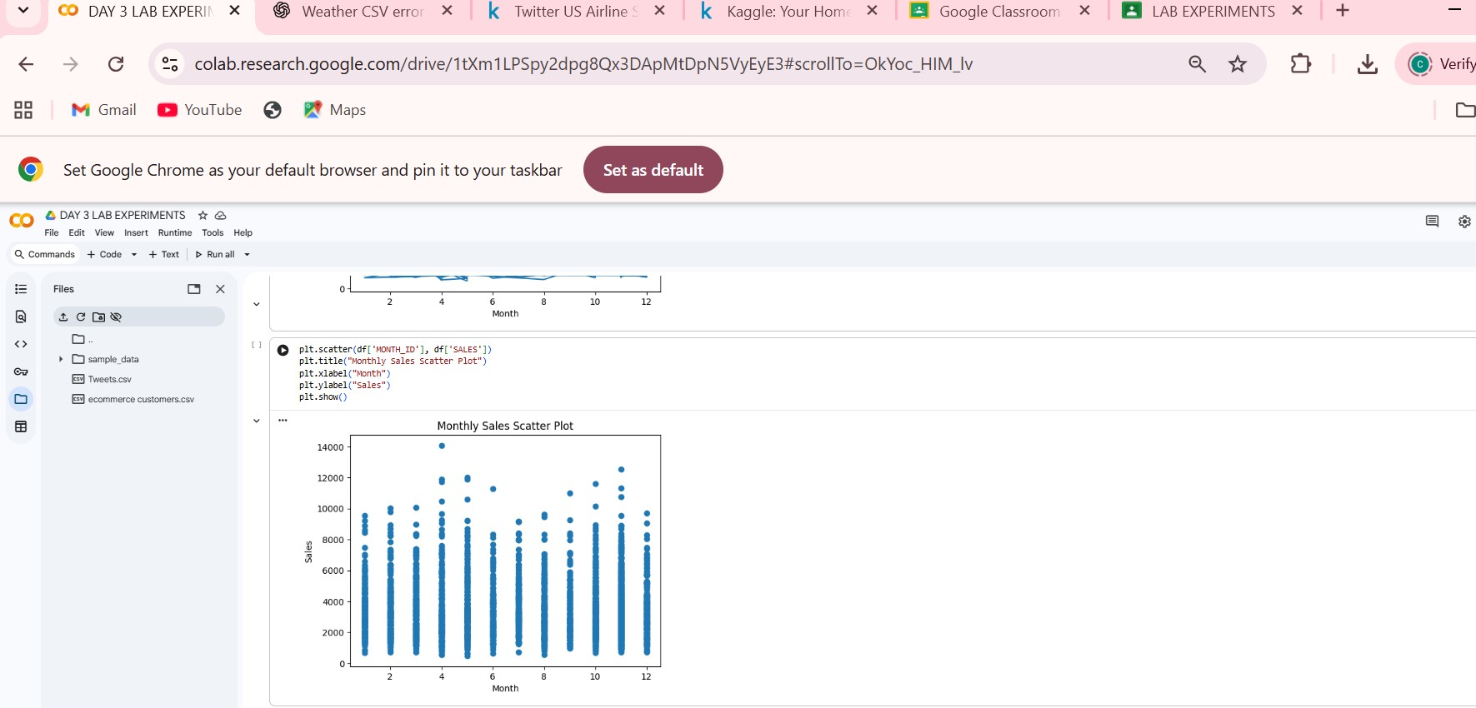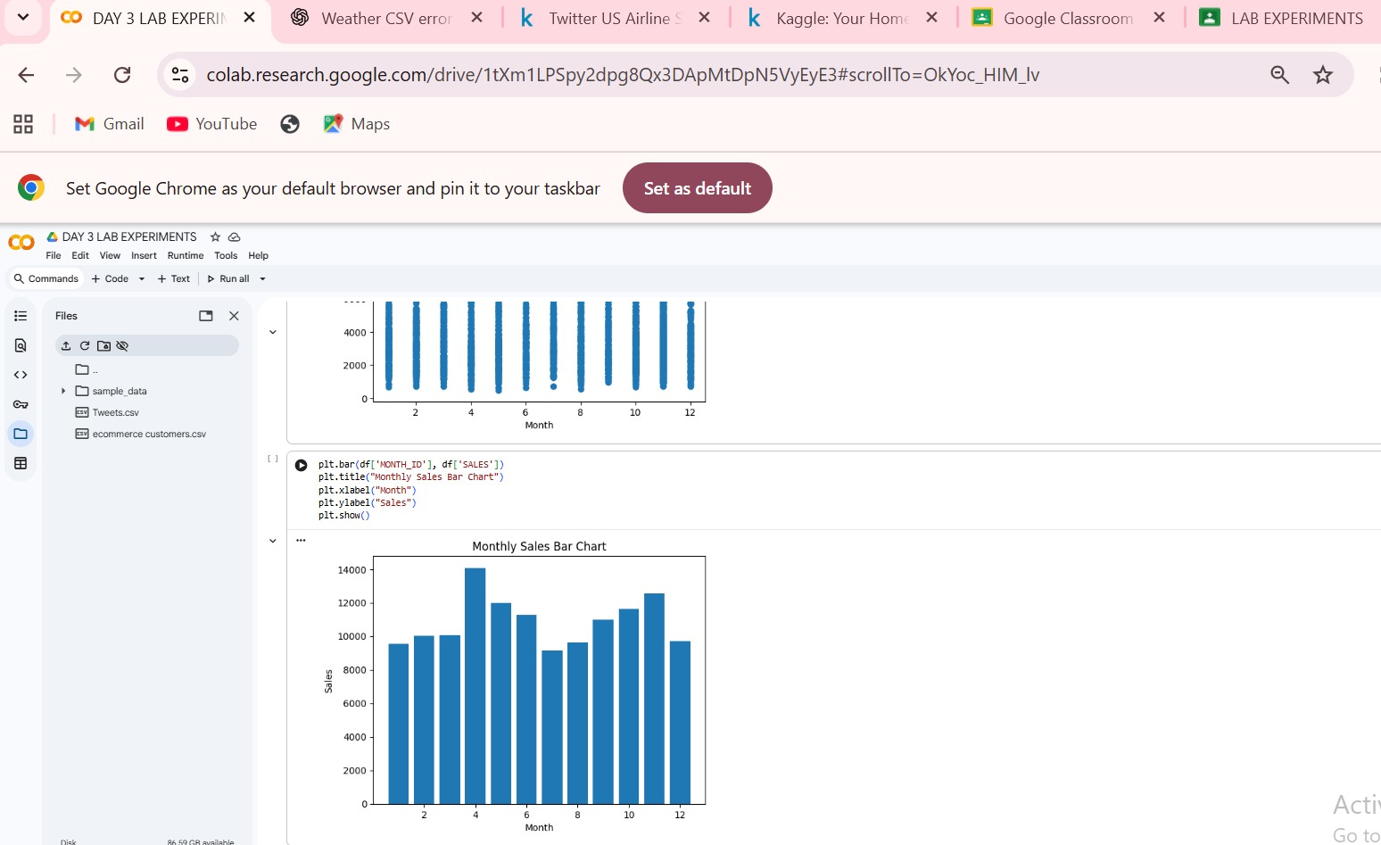

EXP_12 To Develop a Python program that generates line plots and scatter plots to visualize the temperature and rainfall data.
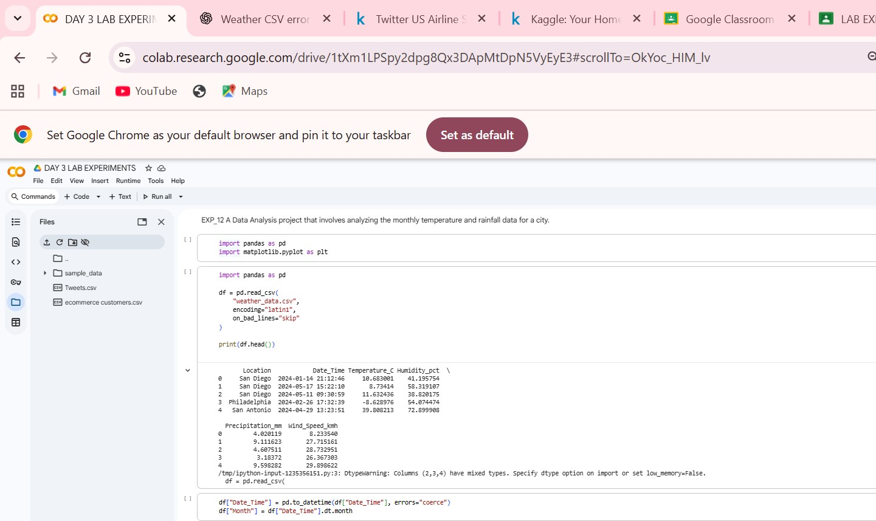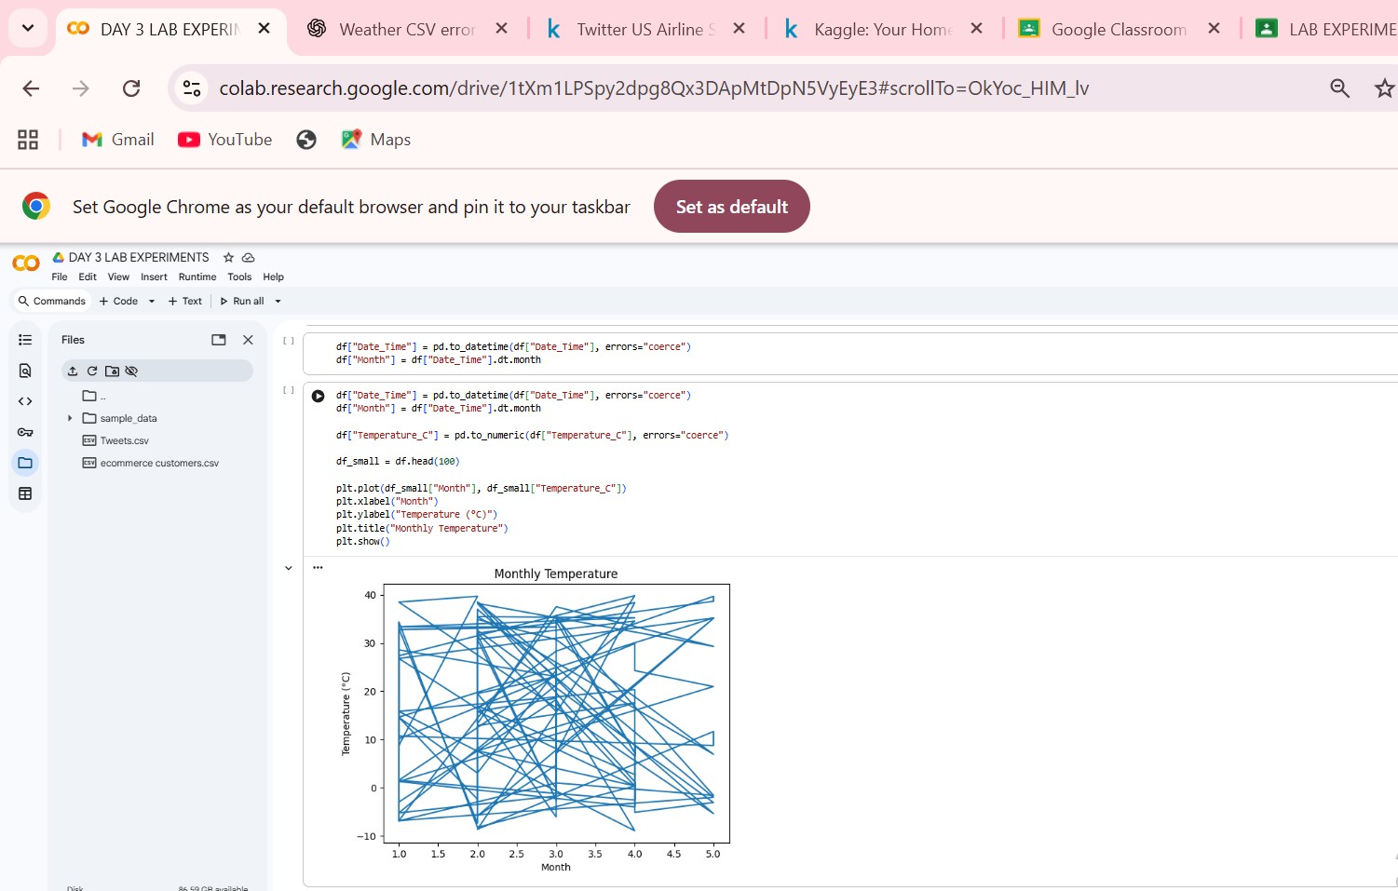
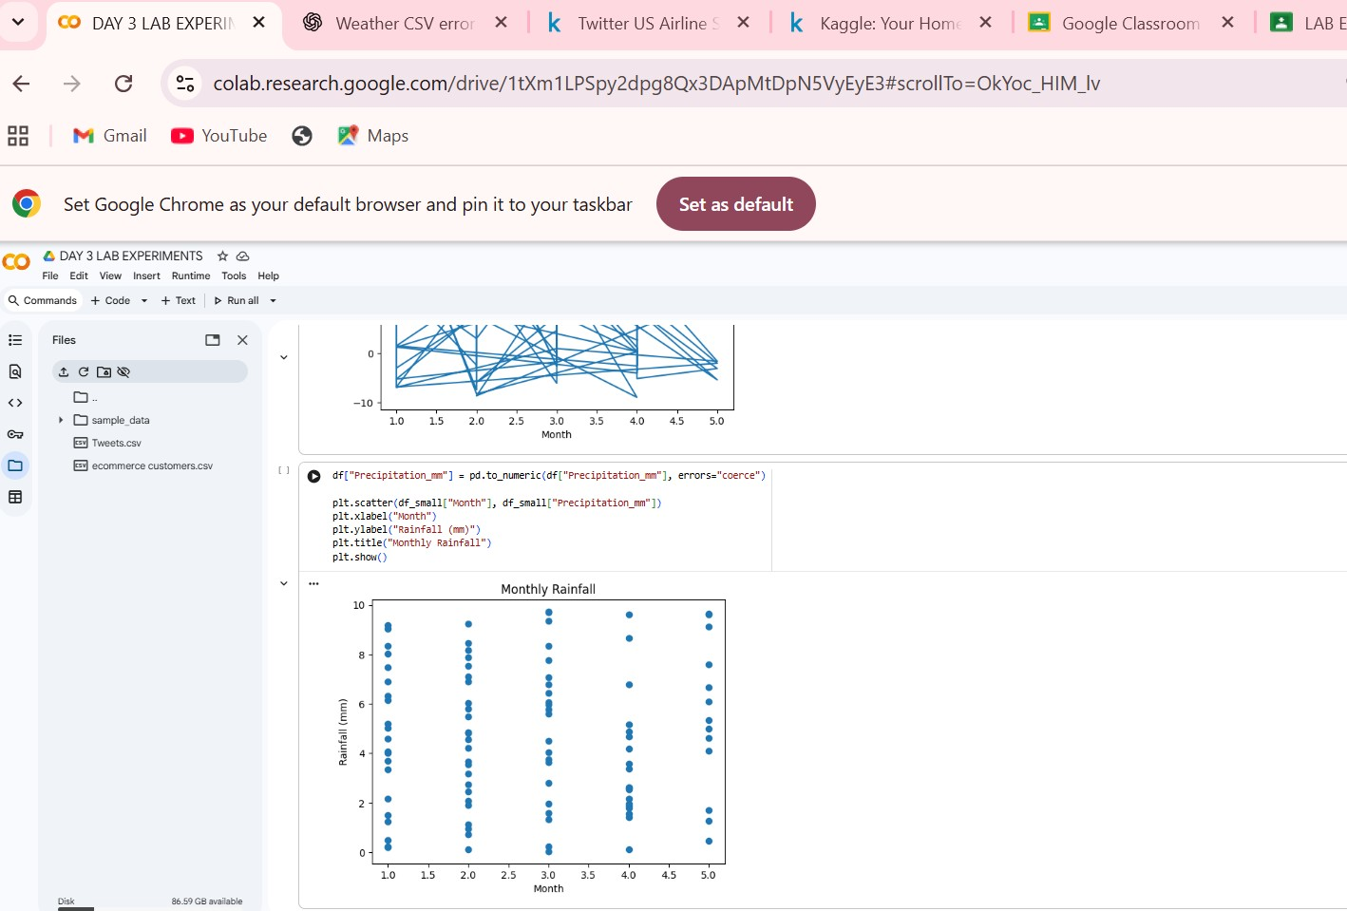

EXP_13 To Develop a Python program that reads the text document, processes the text, and generates a frequency distribution of the words.
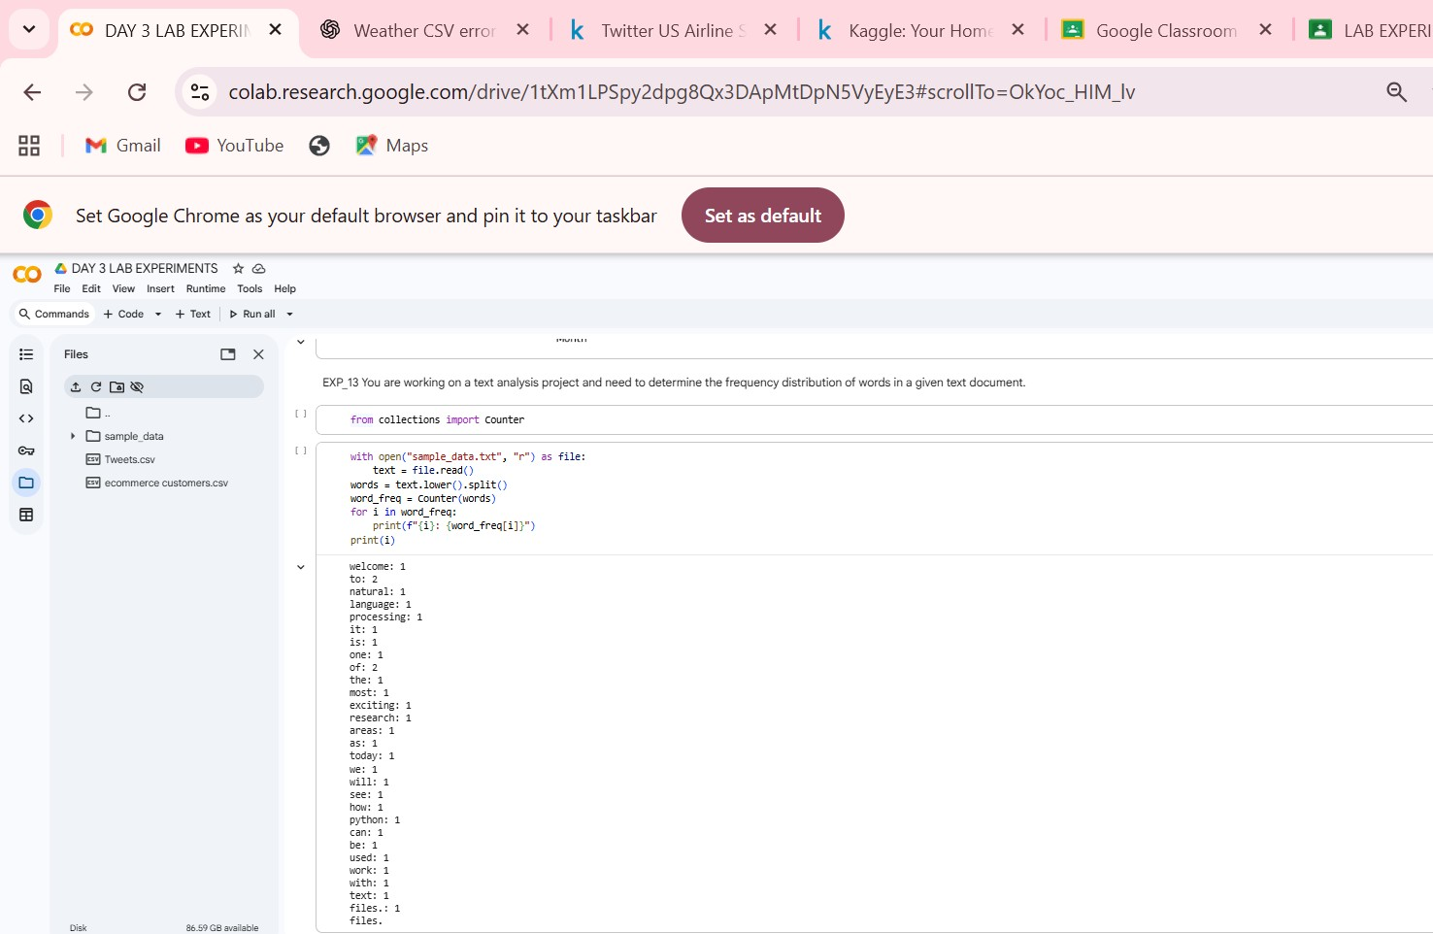

EXP_14 To Develop a code in python to find the frequency distribution of the ages of the customers who have made a purchase in the past month.
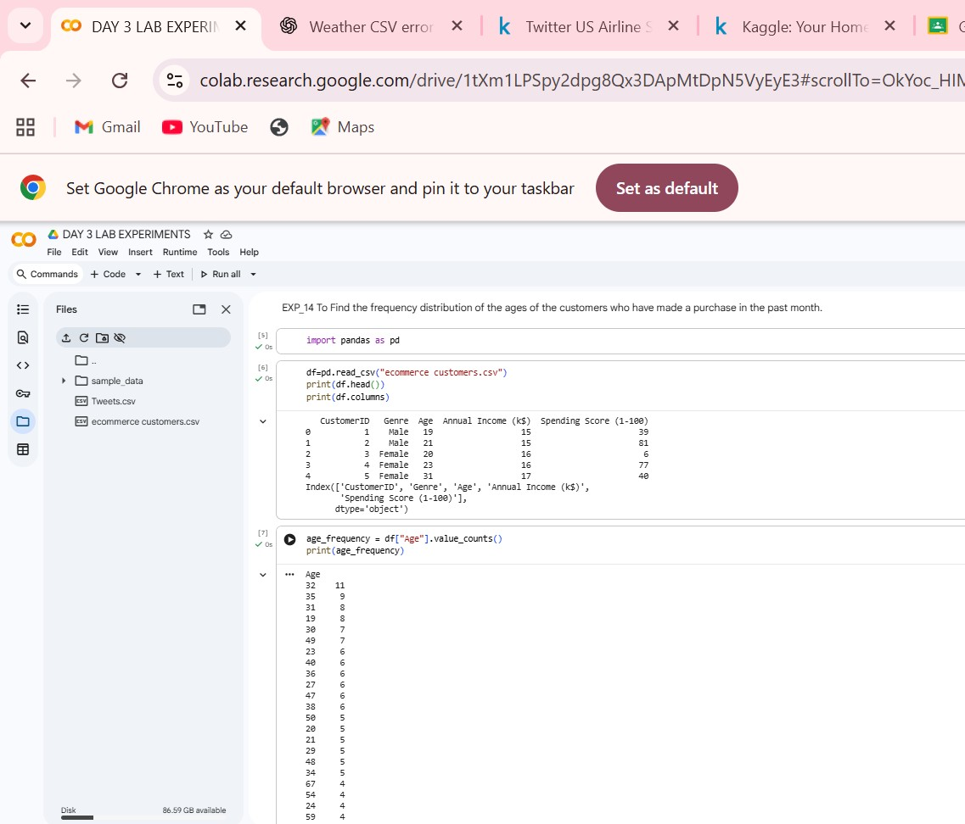
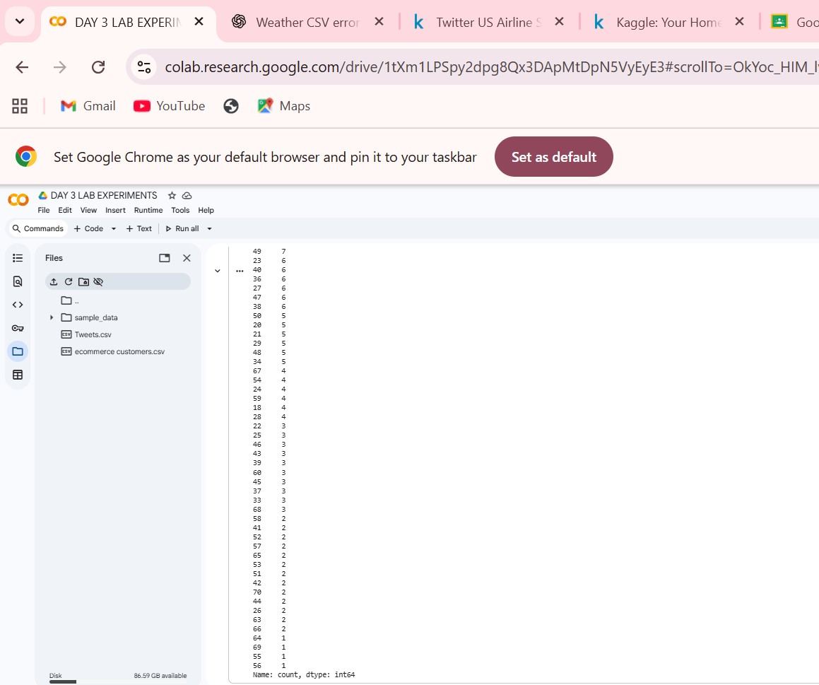

EXP_15 To Develop a Python program that calculates the frequency distribution of likes among the posts.
